CASE 2:NORTH-POINT SOFTWARE MAILING ANALYTICS
Name: saichand cholleti
Student ID: 4256116
INTRODUCTION:
North-Point is a software company which sells games and educational software, and it wants to increase its customers so recently it has joined with a shared company which is specialized in computer hardware and software products and this consortium gives the opportunity to companies which join them to participate in pool .By participating in this pool north-point company can increase its customers because this offers companies participating in this pool can share their customers names as well as get new names from other companies in same number as they shared.
North-point has selected 20,000 names from pool so now they can pick equal number and it gave 1065 purchasers which has response rate of 0.053.So to increase performance project , dataset we use will have total 2000 out of which there are 1000 purchasers and 1000 non-purchasers and in this project we will be using different predictive models for analyzing which customers are purchasing most and these models will pick the correct names and it will be very much useful for north point to send promotions to these persons only and it can increase revenue of company and buyers.

BUSINESS PROBLEM:
North point is sending promotions to all customers which is waste of sending mails to unwanted customers which causes waste of resources and reduces campaign profitability. The test mailing also showed a response rate of 5.3% which shows no return is brought.
Selection of customer names is not done in an accurate way, so which results in increasing cost of mailing campaign.
North Point is also not focusing on existing high-value customers and not designing efficient strategies to retain them, which will increase the risk of losing repeated buyers, which says it does not have strong customer retention strategy.
BUSINESS GOAL:
North point should focus on sending promotions to buyers which will help in increasing profitability by eliminating unwanted buyers from mailing list which also increases response rate to 10% and decreases promotions to non-buyers which helps in reducing wasted resources by at least 20%.
Grouping of customers is done into high-value buyers, medium-value buyers and one-time buyers and focus on giving promotion to High value buyers and make medium-value buyers to high value loyal buyers by giving targeted promotions to them and one-time buyers can be given selective promotions but not that much priority which is given to medium-value buyers which helps in avoiding wasting resources
We will developing different loyalty programs to keep loyal high-value customers which helps us in getting long-term profitability.
ANALYTICAL GOAL:
We will be building different models such as classification and clustering for addressing business problem and we can classify whether a customer is buyer or not and choose buyers which will be helpful in sending promotions to buyers only and we can reduce wasted mailings and increase the response rate above 5.3% and improve campaign profitability and we segment customers to different groups such as high-value , medium-value and one-time buyers by making medium-value buyers to high-value buyers and one-time buyers are given least preference.
ANALYTICAL APPROACH:
This is the step in which we will define which models we are building and what predictors we are using. We can build logistic model which help in classifying whether a customer is buyer or not and send mails to buyers only and we use purchase as target variable and many variables such as gender, frequency etc. as predictors and we have used different thresholds (0.4, 0.5, 0.6, 0.7) to maximize buyers capture and minimize wasted promotions. Random forest is best in capturing non-linear relationships and predictor interactions and variable importance plot is also plotted and it is very much useful in identifying key predictors influencing purchase and for clustering we can group customers into different groups based on response patterns such as High-value, medium-value and one-time buyers, so it will make good strategies of business goals and for clustering we have used k-means which will pre-specify number of customers(k) and we used k=3 and also built Hierarchical clustering model which builds tree like structure which will be helpful to visualize nested groupings of customers and cluster quality will be evaluated using silhouette scores and it helps in achieving customer retention and loyalty programs which focuses on converting medium-value buyers to high-value buyers for long-term profitability.
DATA PREPROCESSING:
The process of cleaning the data and transforming it for analysis is called data preprocessing. The missing values, outliers and duplicates either be removed or addressed so that our data will be well structured which is ready for modelling and our models will give desired outputs with better accuracy.
Attributes Definition:
In our dataset we have 2000 rows and 25 columns
Sequence Number: It represents the row number
US: It says whether purchaser is a US address or not (if Yes =1, No= 0)
Source: It says source list for the record – 15 possibilities which means there are 15 companies
Freq: It is the frequency, and it says number of transactions last year at source
Catalog. which means how many times customers visited.
Last update days ago: It says how many days ago the last update was made to
customer record.
1St update days ago: It says how many days ago the first update was made to
customer record.
Web order: It says whether a customer placed atleast one order via web or not (If
Yes = 1 and No = 0).
Gender = male: It says whether a customer is male or not (If male Yes =1 and
No =0).
Address is res: It says whether the customer is resident or not (If Yes =1 and
No = 0).
Purchase: it says whether a customer made purchase in test mailing. (IF Yes =1
and No =0
Spending: It says how much money the customer spent in test
mailing.

Data Exploration:
We will be observing any missing values or null values present in our dataset if present then we will be handling with advanced data handling techniques such as mean or knn imputation etc. and if they are not useful then we can remove them.
Str(mail):
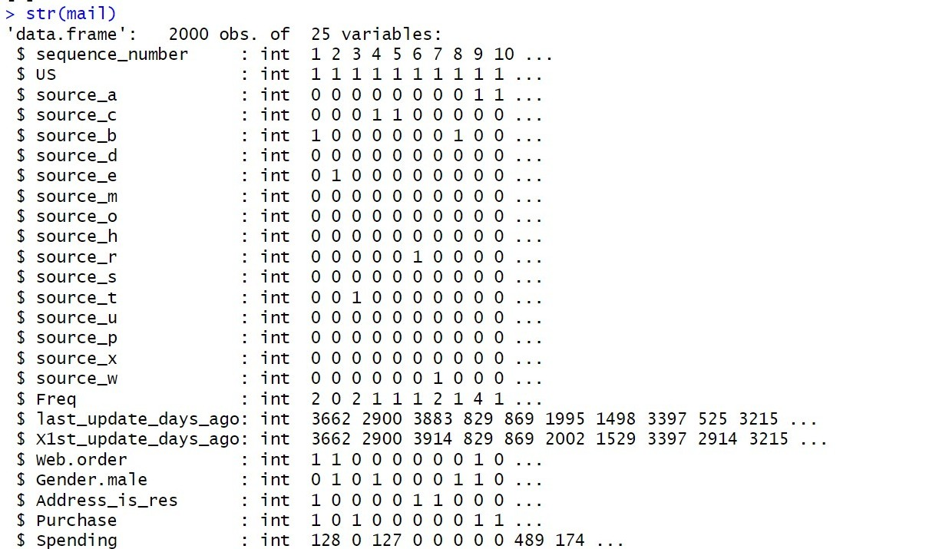
Figure 1. str(mail)
The image gives the description of data type of each variable, and we can see frequency, last update days ago, 1st update days ago, spending is numerical and us, sources, web order, gender male, address is res, purchase are binary.

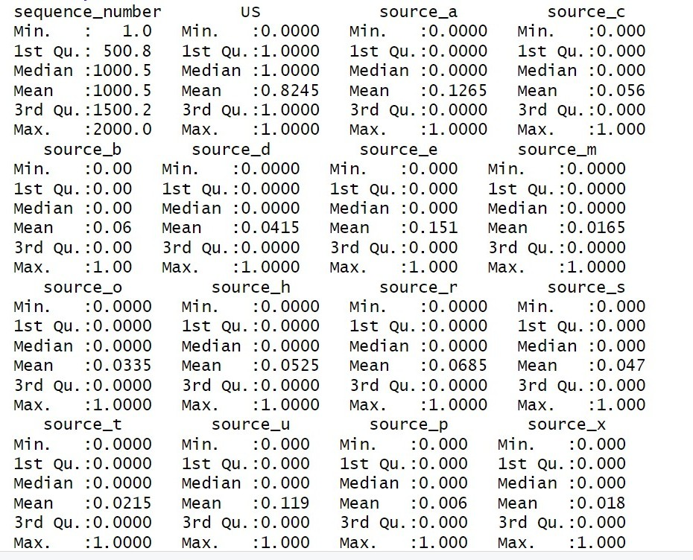
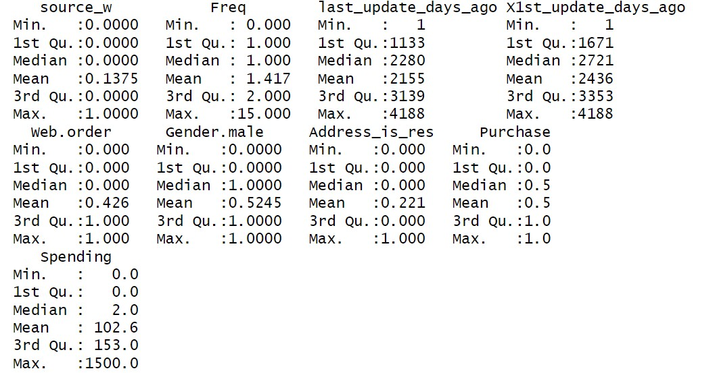
Figure 2 . Summary for dataset
This is the summary of dataset which gives the information about distribution of each variable. It gives info about min value, max value,1st quartile and 3Rd quartile values help in knowing lengths and distribution of each variable. And it gives information about what is minimum value and max value for a numerical column and for binary column it just gives 0 and 1.
Checking missing and zero values:
After carefully checking there are no missing values in dataset. And in some rows, we have where frequency = spending = purchase =0 which may say that the company might have given the product for free or it is returned by a customer.
Scaling is applied to numerical variables Frequency, spending etc. to ensure fair weighting in distance-based methods like clustering.
Binary and categorical variables such as gender=male, address is res, web order were converted into factors to be properly handled in classification models.
VISUALIZATIONS:
Frequency of purchases:
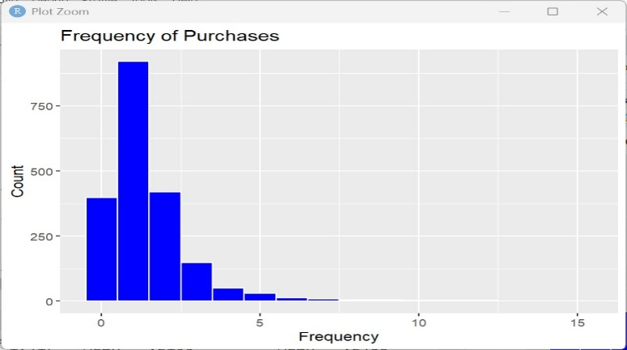
Figure 3.Frequency of purchases
The above plot is Frequency of purchases made by customers like how many times does customer is repeatedly buying products and we can see most customers are repeated 2-3 times and for 5-15 times no customers are there. And this helps us in classifying a customer as buyer or non-buyer.
Distribution of spending:
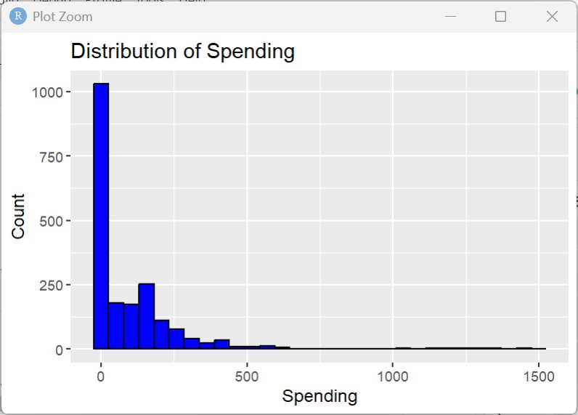
Figure 4.Distribution of spending
This plot is distribution of spending, and it says how much money the customers are spending, and we can see most customers are around 0-250 in dollars and some customers are spending over 1000, and we can say as outliers. So, this helps us to know how much the customers are spending.

Spending vs Purchase:
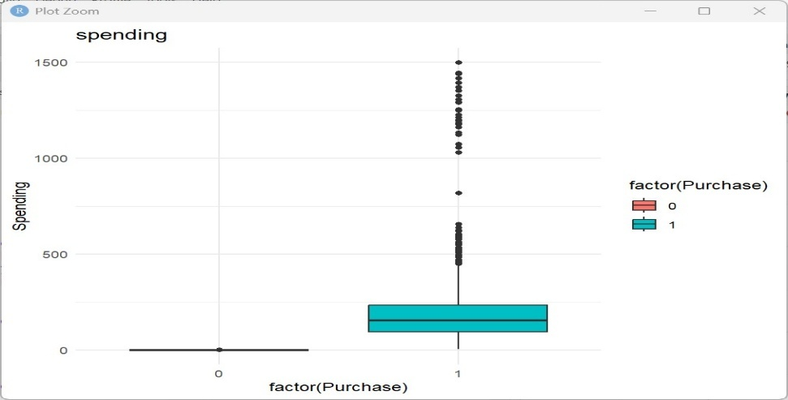
Figure 5 Spending vs Purchase
In this boxplot we can see 0 = group of customers who did not purchase and 1= Group of customers who did purchase. For 0 there are no buyers and for 1 the value is around 200 so this says the buyers are spending less than 200 and remaining half are spending above 200 and some buyers are spending more than 500 and they can be outliers. And this helps us in classifying buyers and non-buyers.

Spending by Gender:
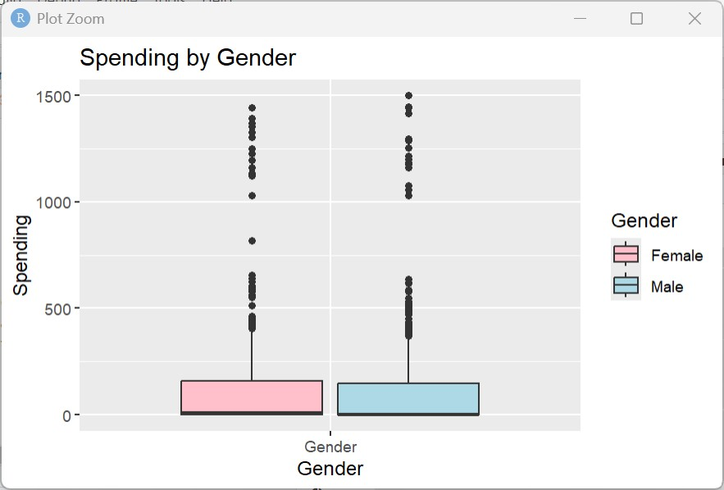
Figure 6 Spending by Gender
In this plot we can see two genders and the median spending of the male customers is around 100-120 and females are spending around 100.So we can use this in knowing which gender is more spending in our products.

Spending vs Frequency:
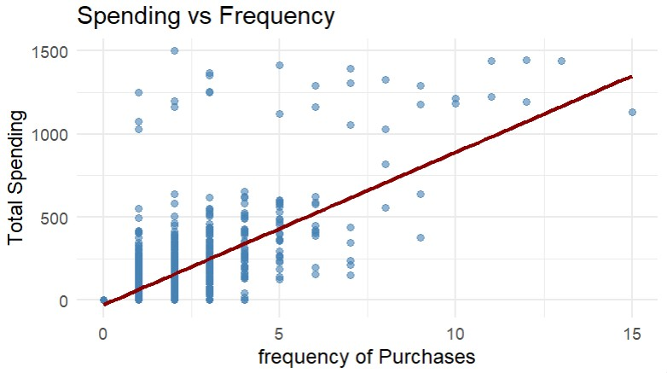
Figure 7 Spending vs Frequency
This is a Scatterplot which is a relationship between Frequency of purchases and Total Spending and this plot tells how frequently the customers are making purchases and how much they are spending in total. As we can see the red line is regression line which indicates that as purchase frequency increasing the spending is also increasing which suggests that frequent buyers are high-value customers.

Top 10 Sources:
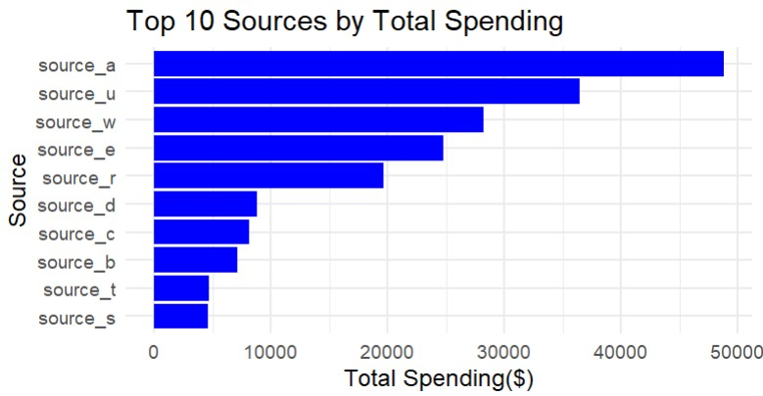
Figure 8 Top Sources
This is a bar plot of Total Spending vs Sources and we can see source a, source u, source w are performing well in generating revenue while source t, source s generating less revenue and we can prioritize promotions to top sources and we can exclude source t, source s which may help in reducing wasted mailings and marketing cost and increase buyers efficiently while reducing medium spenders .

Recency vs Spending:
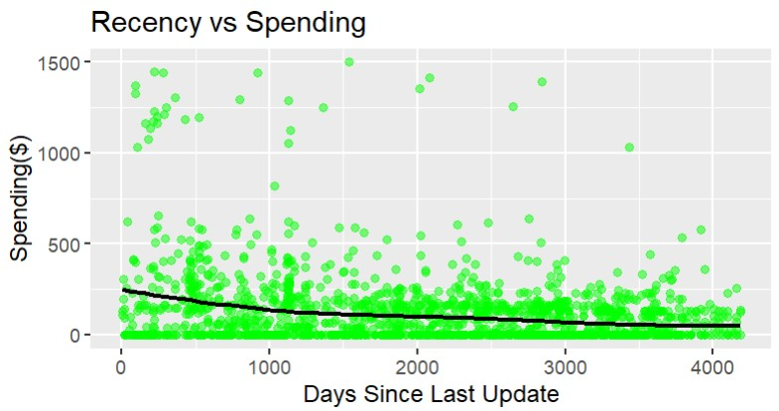
Figure 9 Recency vs Spending

This is a Scatter plot which shows if spending is high for the customers who are recent, and spending is decreasing as number of days since last update increases and the black line is sloping downwards which indicates that recently engaged customers are more valuable.

Correlation Heat Map:
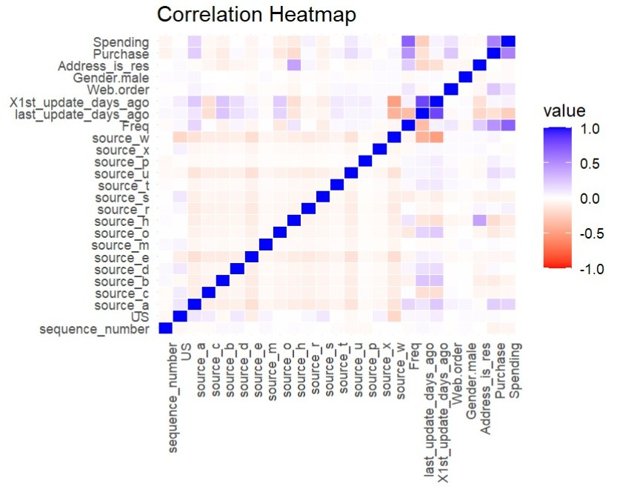
Figure 10. Correlation Heat map
This is a correlation map in which we can see which variables are highly correlated. Blue color says positive correlation; red color says negative correlation and light shades says no correlation.
Spending vs Purchase: Strong correlation which says buyers are spending.
Spending vs Frequency: Positive correlation which says if customers make high spending, then they will visit more times.
Purchase vs Frequency: Positive correlation which says as frequency is more, so they purchase more.

4.PREDICTOR ANALYSIS AND RELEVANCY:
The predictor analysis is used in knowing which variables are most relevant to our target variable and our dataset contains many attributes such as Sources, Address is res , Gender, Freq, Web orders etc. so we can classify these variables as high-relevant, low-relevant.
ANOVA:
Anova is applied to test statistical relationship between predictors and purchase behavior.
Significant Predictors:
Predictor | Spending | Frequency | Web order | Last update days ago | Sources_a.b,h,o,u
p-value | < 2e-16 | < 2e-16 | <2e-16 | 1.26e-12 | p <0.05

These are significant predictors and show very large, consistent differences between buyers and non-buyers and help in selecting high value names from the pool.
Moderately Significant Predictors:
Predictor | Sources_c,e,t,w
p-value | 0.01 <p 0.05

These predictors are moderately significant, and these are weaker as compared to strong predictors and they may improve model accuracy. If source e is weak but still add some value if customer from this source responds slightly better than average, it’s worth including in predictive model.
Not Significant Predictors:
Predictor | Gender.male | Address_is_Res | Us | Sources_d,m,r,x | 1st update days ago
p-value | 0.347 | 0.829 | 0.318 | p>- 0.05 | 0.0988

These are not significant predictors and adding these in modelling will not provide much predictive power.
VIF:
VIF is used to check multicollinearity among predictors which ensures only relevant,
non-redundant features are included which help in improving model reliability.
Predictor | VIF | Level of Collinearity
X1st_update_days_ago | 5.95 | High
Last_update_days_ago | 5.56 | High
Source_a,e,w | 3.53 – 4.11 | Moderate
Web.order | 1.03 | No Collinearity
In the above table we can see top 5 predictors VIF and in our dataset most predictors have
VIF <5 which says no high collinearity. Both last_update_days_ago and X1st_update_days_ago are highly collinear which suggests redundancy, and we need to drop one for modelling.
5.DIMENSION REDUCTION:
This is used to reduce number of variables in our dataset so that it can be used for modeling, and our dataset has less variables which no need removing of variables and last update days ago and 1st update days ago are highly correlated so we can remove one for modelling which will avoid redundancy.
6.DATA ENGINEERING AND TRANSFORMATION:
In our dataset we have categorical, numerical data so we need to transform this data to get better accuracy in modelling .We have done Z-scaling for numeric variables without scaling a variable like last update days ago would dominate the distance calculation compared to frequency value in single digits which means clustering would group customers mainly by recency of update, ignoring frequency or spending leading to biased and meaningless clusters.
7.DATA PARTITIONING:
In our dataset we have total of 2000 records, which contain 1000 purchasers and 1000 non-purchasers and for this project we have partitioned the data into training and test sets which will help us in training on data and then now we will test it on unseen data. Training percentage I have chosen is greater than 50% because if we choose below that there are higher chances that our model will give biased decisions and training on 70% data it makes the model to learn more on training data. So, I have used 70% for training and 30% for testing and use of set.seed also ensures our analysis consistently and reliable and it gives almost same results.

8.MODEL SELECTION:
Classification model:
Classification model performs best in classifying a variable so in our business we want to classify as buyer or non-buyer so we can send mail to buyers only and we can neglect non-buyers which saves cost by reducing wasted mailings by selecting names from pool with the highest probability of purchase.
Logistic Regression Model:
The classification model selected is logistic regression and target variable is Purchase because we need to select the variable which has binary column and this is a binary column, and this helps us in classifying as buyer or non-buyer and it tells us which variables are most significant in predicting our target variable.
Random Forest Classification:
This is random forest model which will provide high predictive accuracy compared to logistic regression which gives variables importance measures that highlight which features are most influential
K-means Clustering:
Clustering helps in segmentation of customers and makes them as different clusters like high spenders, low spenders and one-time spenders customers and we can send promotions to High, Medium spenders and we can prioritize high, medium spending customers for premium offers and promotions. And we have used K-means clustering by using Freq, spending in this we will pre specify number of clusters.
Hierarchical Clustering:
It is also a clustering model which builds tree-like structures which show nested groupings which will help us to explore customers relationships before deciding how many clusters to cut. So overall, these models solve the business problem by reducing wasted mailings, improving profitability and enhancing customer loyalty
9.MODEL FITTING, VALIDATION ACCURACY AND TEST ACCURACY:
Logistic Regression:
We have used Frequency, Web.order , Gender.male , address_is_res and source indicators as predictors and Purchase as target variable. The dataset is split into 70% for training and 30% for testing and predictions were generated as probabilities and converts into classifications using cutoff thresholds.
At cutoff = 0.4 we got high sensitivity (91%) and high accuracy (83%) which will help in capturing true buyers, which is our business goal of prioritizing buyers in promotions.
Random Forest Classifier:
We have built 500 trees selecting 3 variables in each split and we used 70% for training and 30% for testing. In variable importance plot we got top predictors Frequency, source h, last update days ago, source u and source a.
Roc/AUC showed strong buyer separation.

K-Means Clustering:
We have scaled the data to endure comparability across features, and we have determined number of clusters =3 by using elbow method
Hierarchical Clustering:
We have applied Ward’s method with Euclidean distance and dendrogram cut at 3 clusters for comparison with k-means.
10.REPORT ON MODEL PERFORMANCE:
Logistic Regression:
Cutoff | Accuracy | Sensitivity | Specificity
0.4 | 0.8300 | 0.9133 | 0.7466
0.5 | 0.8100 | 0.8266 | 0.7933
0.6 | 0.7916 | 0.7000 | 0.8833
0.7 | 0.7800 | 0.6166 | 0.9433

At cutoff =0.4 there is high sensitivity (91%) which helps in catching most buyers. Lower specificity (74%) which is more wasted mailings to non-buyers.
At cutoff = 0.5 the sensitivity is 83% and sensitivity is increased which avoids too many wasted mailings while still catching most buyers.
At cutoff = 0.6 the sensitivity is 70% which says missing more buyers and specificity = 88% and fewer wasted mailings.
At cutoff = 0.7 the sensitivity is 62% which says missing many actual buyers and specificity = 94% high which says very little wasted mailing.
And we have chosen cutoff = 0.4 which is high sensitivity (91%) and high accuracy (83%) and AUC value = 0.912 which will help in capturing true buyers and also satisfy our business goal of increasing response rate from 5.3% to 10%.
Random Forest:
Accuracy | Sensitivity | Specificity | AUC
0.8183 | 0.8767 | 0.7600 | 0.9054

We got accuracy of 81%, sensitivity (87%) which is good at capturing buyers, Specificity (76%) which is low at filtering non-buyers and AUC is 90% which is very strong which also maintained a balance trade-off with specificity.
K-means Clustering:
Cluster 1: it has a moderate purchase rate (55%) and it is mid-level size.
Cluster 2: it has high purchase rate (99%) and smallest in size and it represents high-value loyal customers.
Cluster 3: It has the least purchase rate(40%) and large size of customers and it is low-value customers.

Hierarchical Clustering:
Cluster 1: in this we have large group of customers, which is 1013 and it has low purchase rate of 42.9%.
Cluster 2: It is a mid-sized group which has 771 customers and purchase rate is 46.7%
Cluster 3: it is a low-sized group which has 216 customers and very high purchase rate of 94.9%
11.MODEL EVALUATION:
Logistic Regression:
In logistic regression we have used Purchase as target variable and sources, frequency, web order, address is us etc. as predictors and frequency, web order, source a, source h, source u are the most significant in predicting Purchase.
Cutoff | Accuracy | Sensitivity | Specificity | TP | TN | FP | FN
0.4 | 0.8300 | 0.9133 | 0.7466 | 274 | 224 | 26 | 76
0.5 | 0.8100 | 0.8266 | 0.7933 | 248 | 238 | 52 | 62
0.6 | 0.7916 | 0.7000 | 0.8833 | 210 | 265 | 90 | 35
0.7 | 0.7800 | 0.6166 | 0.9433 | 185 | 283 | 115 | 17

At cut of = 0.4 we have highest TP=274 which is best in capturing more buyers and low FN=76 which is missing very few buyers and FP = 26 which is controlling wasted mailings and sensitivity is high (91%) and our priority is maximizing response rate and reduce wasted mailings by choosing buyers we chose cutoff=0.4
ROC Curve:
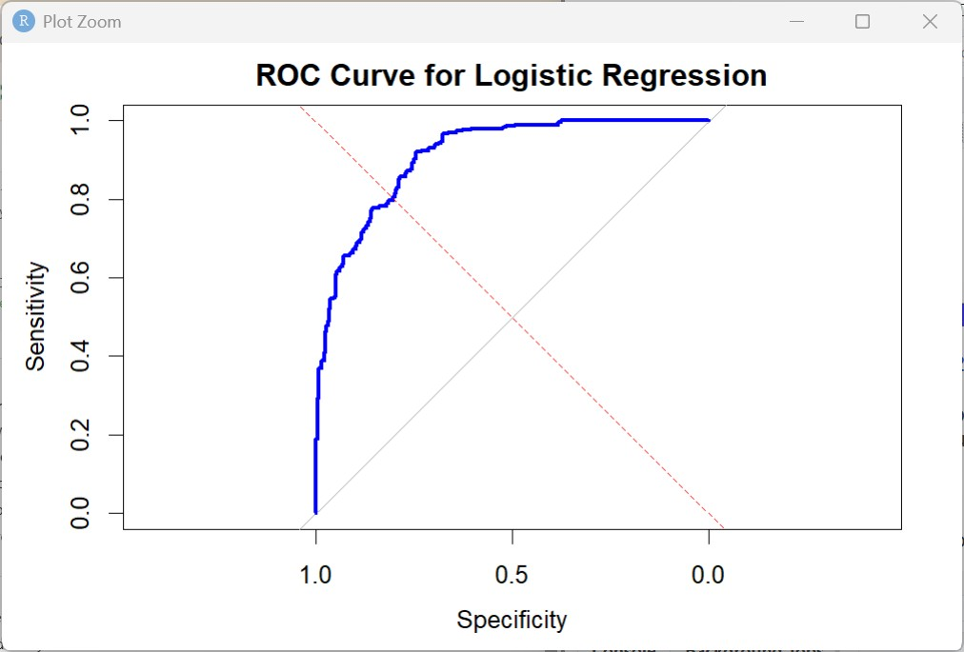
Figure 11 ROC-Logistic
This is Roc curve tells us how well the logistic model separates buyers from non-buyers and the blue curve is above diagonal so model is significantly better than random guessing who will buy and it shows a balance trade-off between sensitivity and specificity .At cutoff 0.4 our model is improves sensitivity which means it is capturing more buyers which satisfies our goal of increasing response rate above than 5.3% and it is also reducing wasted resources by 20%.

Random Forest Model:
 | Predicted No-buyer | Predicted Buyer
Actual non-buyer | TN = 228 | FP= 72
Actual Buyer | FN = 39 | TP = 261

In Random Forest model we got TP = 261 which so we can say it is capturing high proportion of buyers close to logistic regression and FP = 72 which is more than logistic regression so we can say Random Forest helps in sending more promotions to non-buyers and sensitivity is 87% which is low which misses more buyers.
ROC Curve:
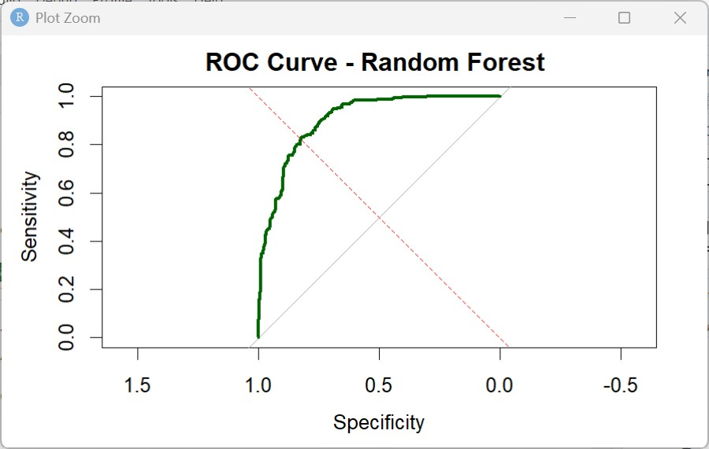
Figure 12 ROC-Random Forest
This curve shows how well the random forest model separates buyers from non-buyers and it is close to top-left so we can say model is accurate. The model has high sensitivity, and it also helps in reducing wasted resources and boosting profitability.
K-Means Clustering:
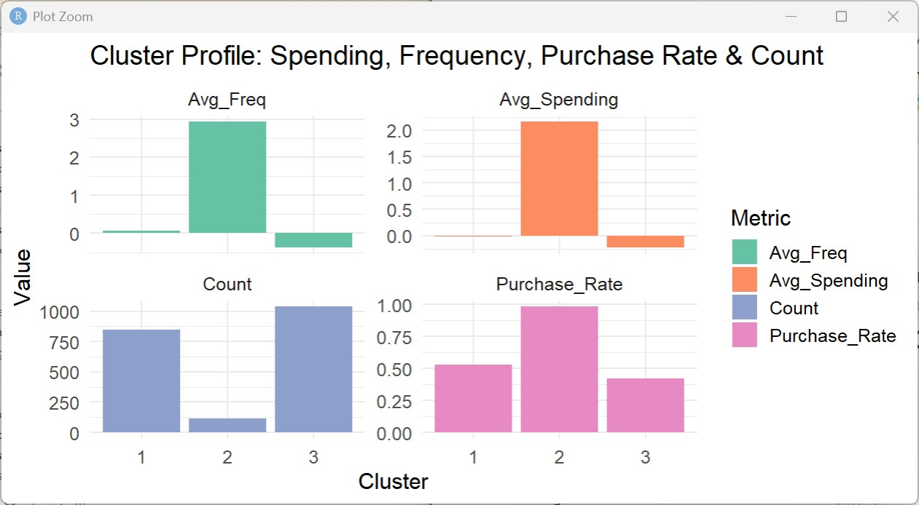
Figure 13 Cluster Profile-K-means
Cluster 1 -Medium buyers:
This represents medium value segment, and these customers buy occasionally and generate steady but not high profit, and we can move them to cluster 2, which is high-value loyal buyers by providing targeted promotions.
Avg spending: low
Avg Frequency = 0.07
Purchase Rate = 55%
Customer Count = 850

Cluster 2: High-value loyal buyers
Avg Spending =2.16
Avg frequency =2.93
Purchase rate = 99%
Customer count = smallest group
These are loyal, high-value customers contributing maximum profit and purchase consistently. Loyalty programs, VIP offers are to be given to these customers.
Cluster 3: One-time buyers
Avg spending = -0.227
Avg frequency = -0.378
Purchase Rate = -40%
Customer count = -1050
These are one-time customers, and we can send less promotions to these customers as compared to medium-value customers and excluding these customers from expensive campaigns will reduce wasting resources by atleast 20%

Hierarchical Clustering:
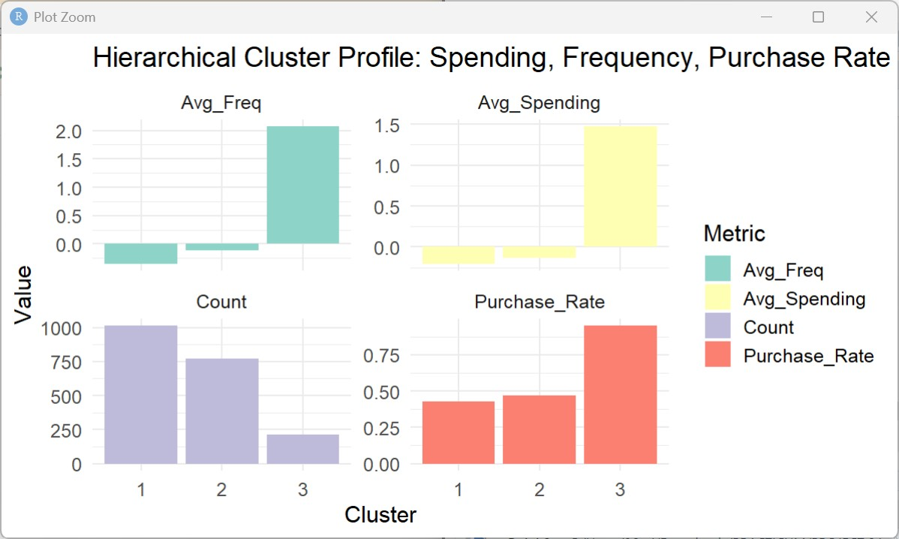
Figure 14 Cluster Profile -Hierarchical
Cluster 1 (1013 customers, ~ 43% buyers
From the figure we can see low purchase rate, below avg spending and low frequency and this is one-time buyers so we can reduce promotions here which will help in 20% reduction in wasted resources.
Cluster 2 (771 customers, ~47% buyers)
In this cluster 2, we can see frequency is moderate and medium purchase rate and these are convertible customers which means medium-value buyers so targeted promotions and loyalty offers can make them to move to high-value segment and this will increase response rate from 5.3% to 10%.
Cluster 3 (216 customers, ~95% buyers)
In this cluster we can see frequency is very high as compared to cluster 1,2 ,high spending, and high purchase rate and these are loyal high-value customers and we need to give them loyalty programs and personalized promotions to retain them which will help in long-term profitability.
Dendrogram:
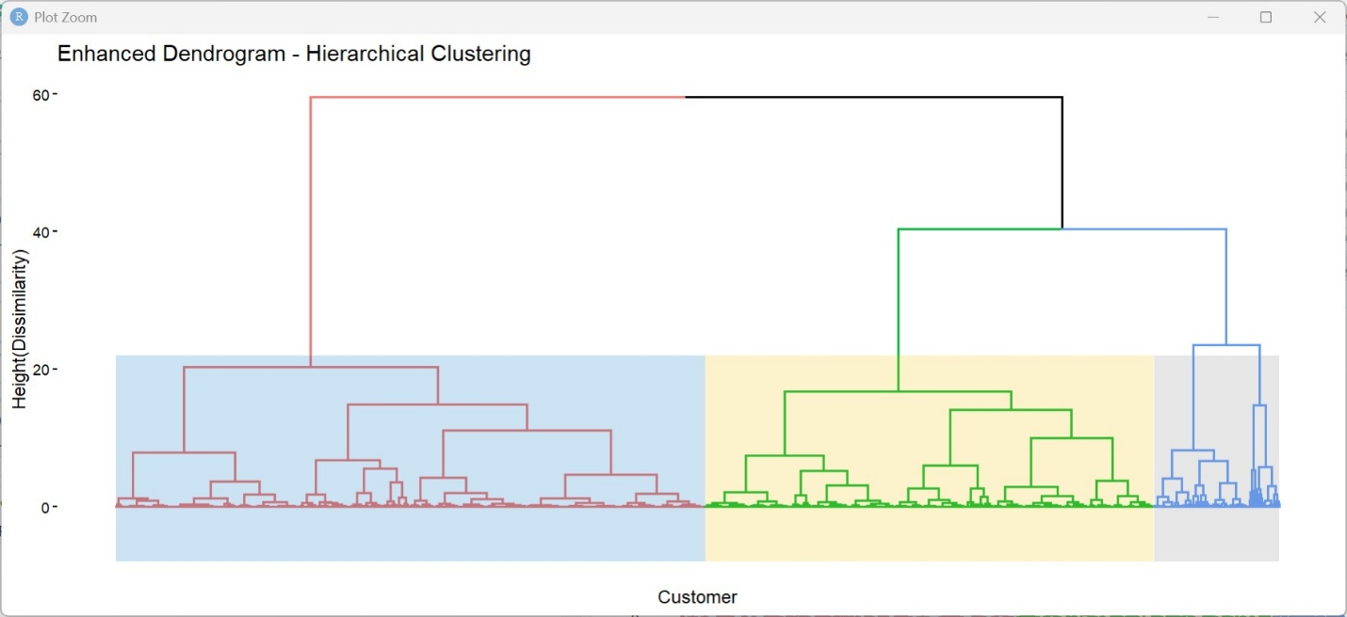
Figure 15 Dendrogram
The above figure is a dendrogram which segments customers and it explains how customers are grouped into clusters based on similarity in the variables and it helps in identifying buyer groups and guiding promotions toward profitable clusters.
Cluster 1(blue): It is a large group which is mostly low-medium spender which is less profitable.
Cluster 2(Yellow): It is a mid-size group, and it is medium-value buyers who can be converted to high-value buyers.
Cluster 3(Grey): It is the smaller one and it is a clear group of high-value loyal buyers
12.OBSERVATIONS AND CONCLUSIONS:
The logistic regression achieved an accuracy of 83% and sensitivity of 91% and specificity of 74% which tells us that our model is effective in capturing buyers and wasted mailing rate is reduced to 12.6% and response rate is improved to 45.7% in test sample(scaled back to ~10% real-world using 5.3/50 adjustment).And Random forest with wasted mailing rate 11.8% and response rate 43.6% in test sample.
The k-means clustering (k=3) produced three different customer segments cluster 1,cluster 2, cluster 3 and cluster 2 is High-value customers with the high spending and purchase rate(99%) whereas cluster 1,3 are medium , one-time customers with different purchase rates suitable for selective promotions and Hierarchical clustering also has three major customer groups with similar patterns confirmed by dendrogram which k-means has average silhouette value of 0.492 has performed better than hierarchical clustering which has average silhouette value of 0.478 .
So, overall logistic regression model at cutoff = 0.4 gave an accuracy of 83%, sensitivity of 91% which helped in capturing more buyers effectively and also helped in increasing response rate to 10% and k-means clustering has segmented the customers accurately which makes us easy to give promotions and loyalty programs to high value customers and it also helps in converting medium value customers to high values customers which helps in reducing wasting resources by 20% and increase long term profitability. If customer age, region, income level are added in dataset so we can easily track monthly patterns to adjust campaigns during high-conversion periods. And if customer info, location, and product category is added then we can particularly focus on specific customers so that sales and revenue can also be increased

EXECUTIVE SUMMARY

